How to Access Your Telehealth Session from a MacBook

OPTIONS
- Safari will not run Microsoft teams, so they are two options below that will work for sessions from a mac book.
  - I will show you how to do both below.

- Install google chrome and use that to join the meetings online

- Install Teams on your device and use that to join

Installing and Using Microsoft Teams
- Open the Session invite from your therapist and click on the purple JOIN MICROSOFT TEAMS MEETING link

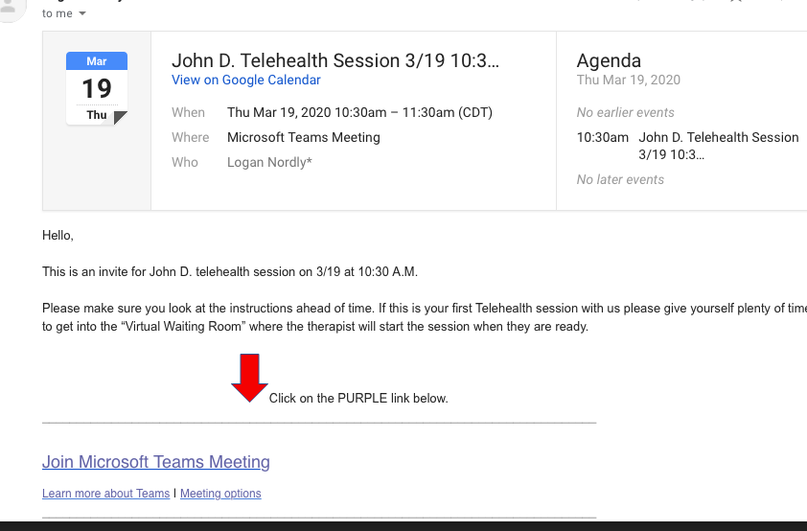

- Click on Get the Teams App

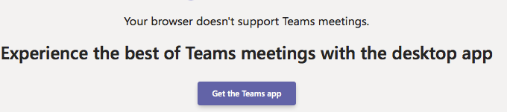

- Clicking on that should start a download for TEAMS. You should see your download icon show up on your system bar.
  - If you don’t see that click on the link again and check your downloads folder
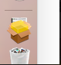

- Once in the download folder click on the TEAMS package to start the install
  - You should be able to install this program like any other. Next and continue your way though.

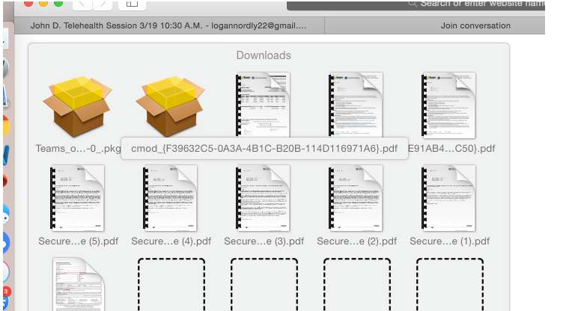

- Microsoft Teams should now be installed and ready to use. There should be an icon like you see below
- Once you have teams installed you can skip down to the Section called Joining Telehealth Session

Installing and using Google Chrome

- If you want to download google chrome and use teams online, you can follow the link below for those instructions
https://support.google.com/chrome/answer/95346?co=GENIE.Platform%3DDesktop&hl=en-GB

How to Join Your Telehealth Session from Your MacBook

- Click on the purple JOIN MICROSOFT TEAMS MEETING link in the email your therapist sent you.

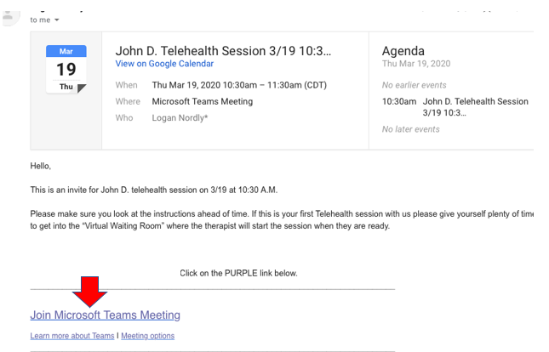
- If you installed the Teams app that should automatically open.
  - If you are using google chrome, then choose JOIN ON THE WEB INSTEAD

- You should get the screen below. Make sure that your camera and microphone slides are PURPLE. Also put the kiddos name in the blank and click join now.
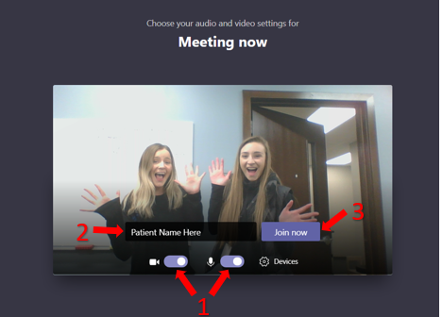
- You should now be in the “virtual waiting room” and your therapist will accept you into the session when they are ready.
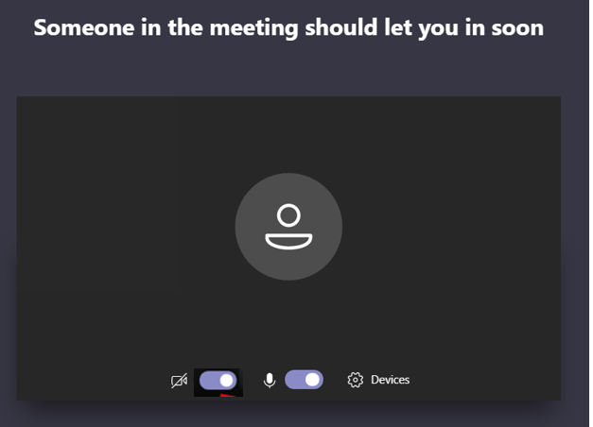

- When the session is finished you can hand up by clicking on the red phone icon.
